1.  Provide screenshots to show package status of *all* packages at a time between 8:35 a.m. and 9:25 a.m.

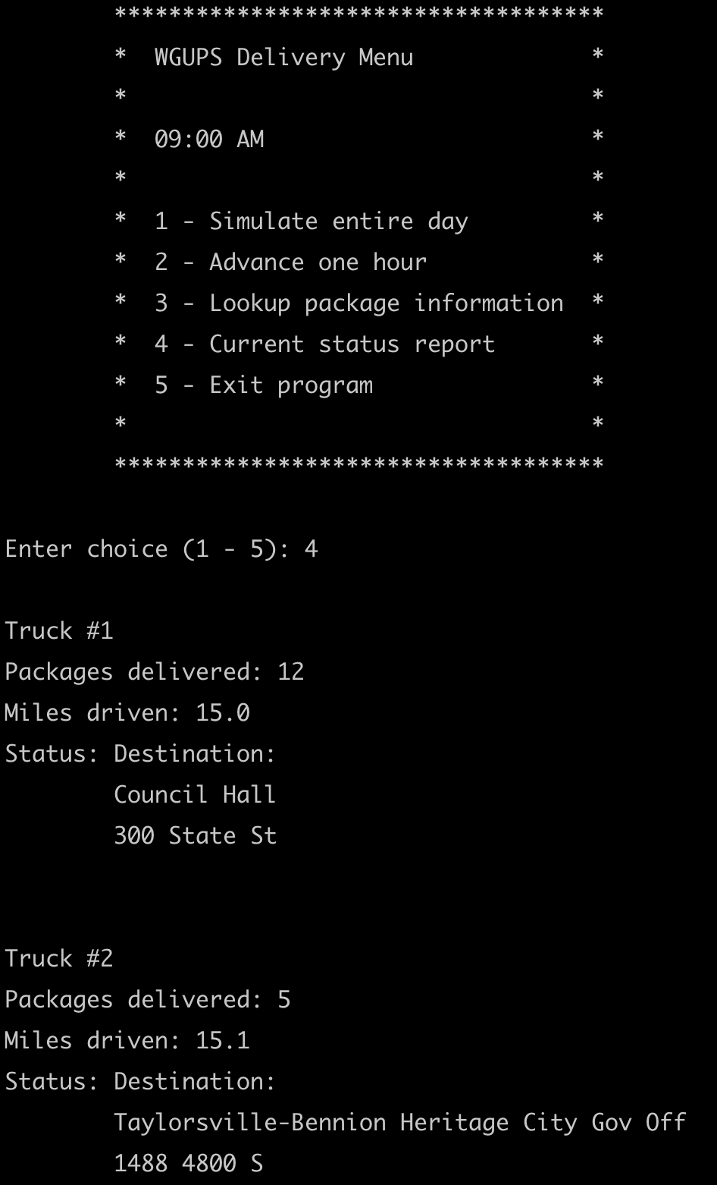

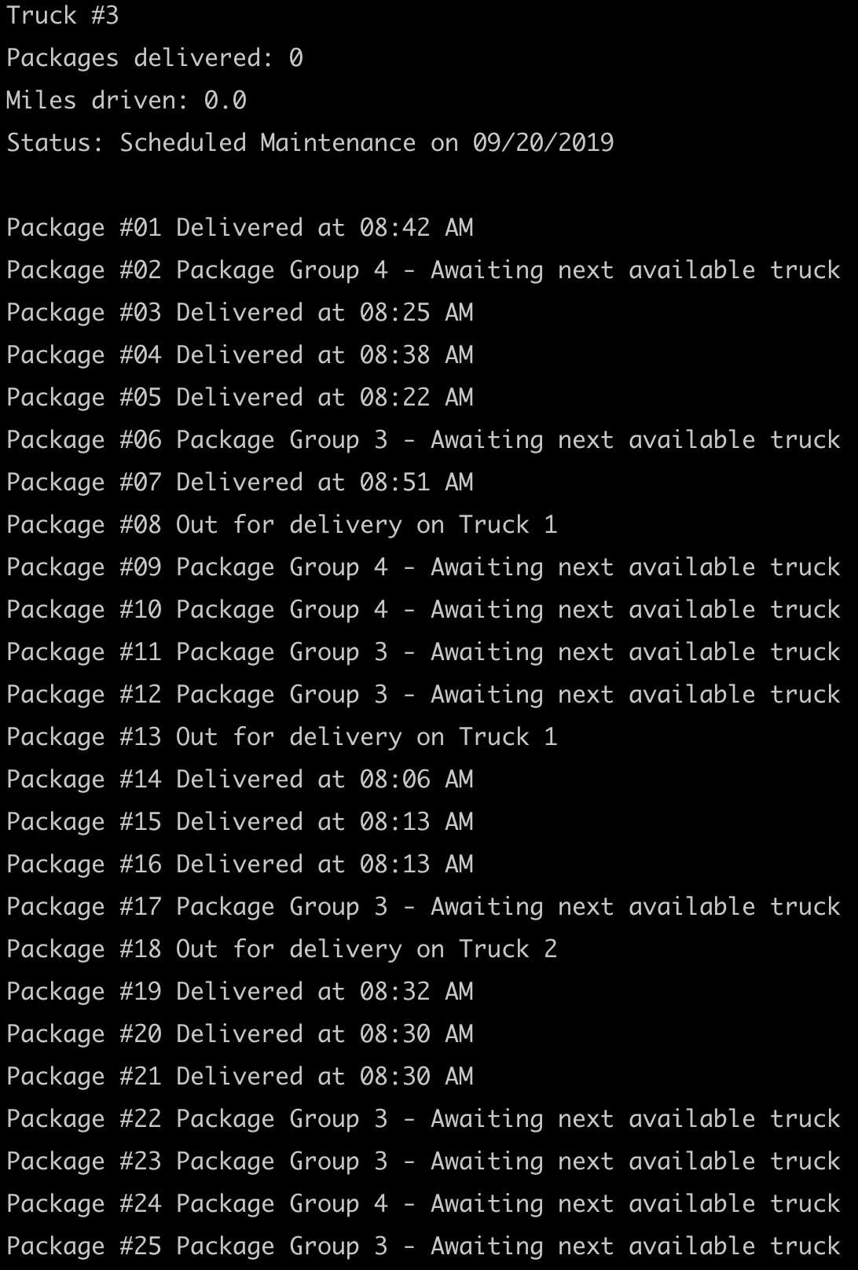

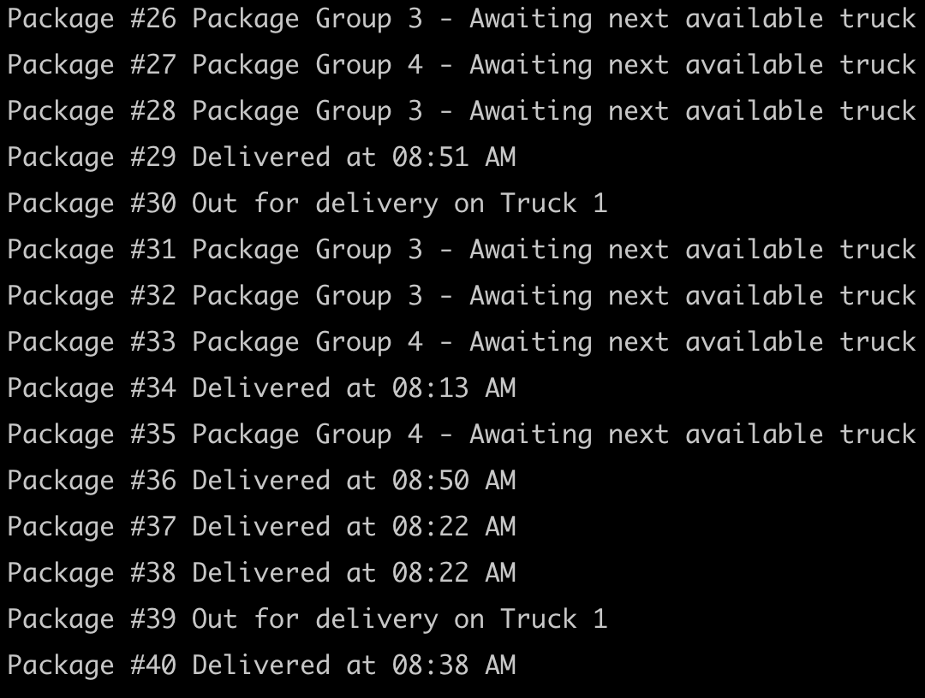

2.  Provide screenshots to show package status of *all* packages at a time between 9:35 a.m. and 10:25 a.m.

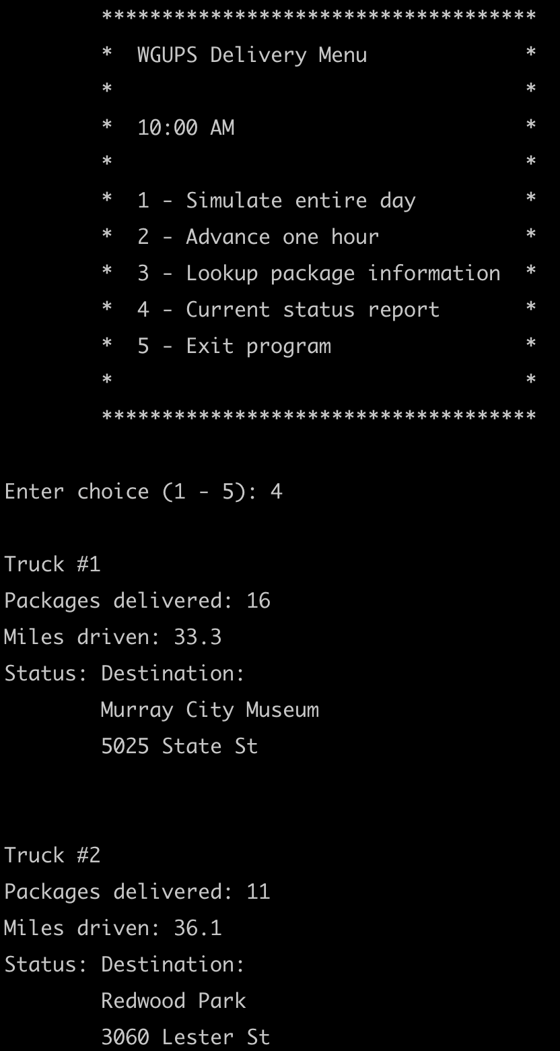

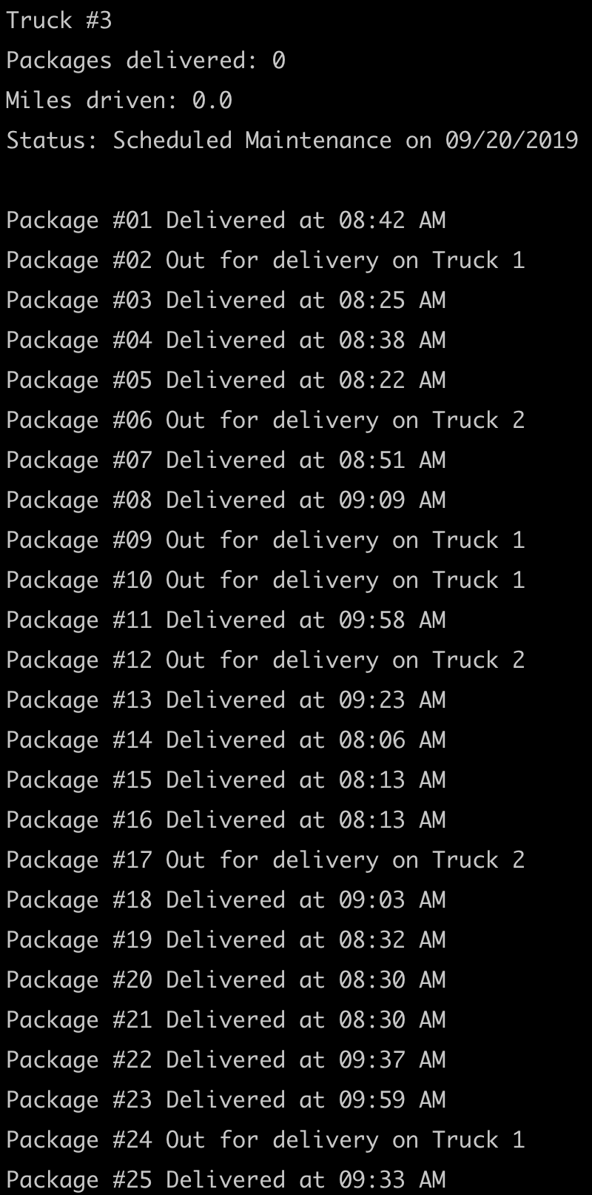

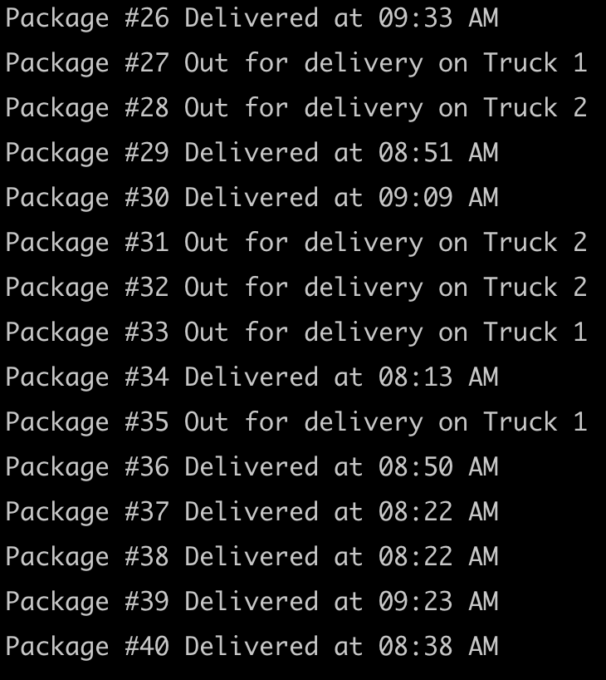

3.  Provide screenshots to show package status of *all* packages at a time between 12:03 p.m. and 1:12 p.m.

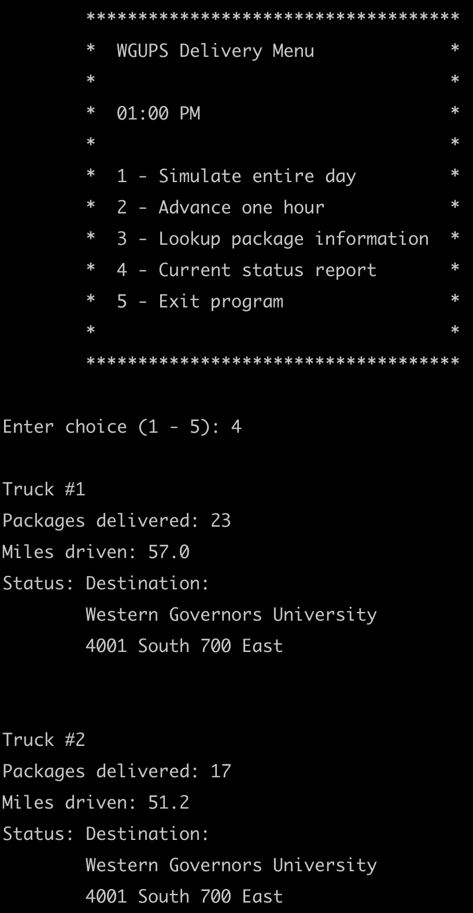

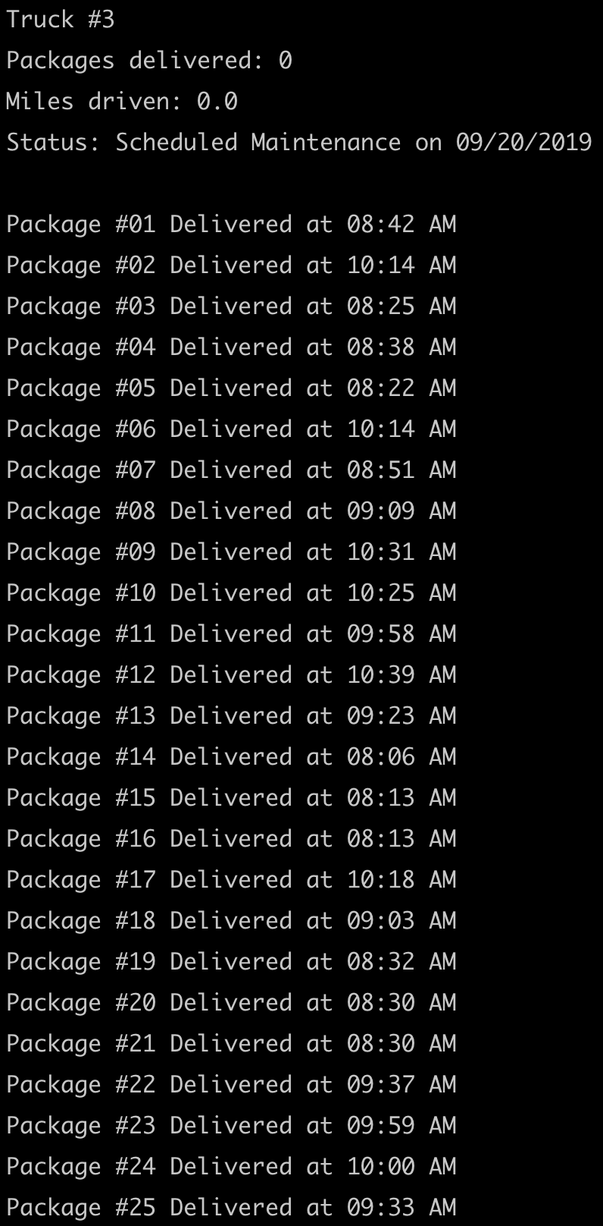

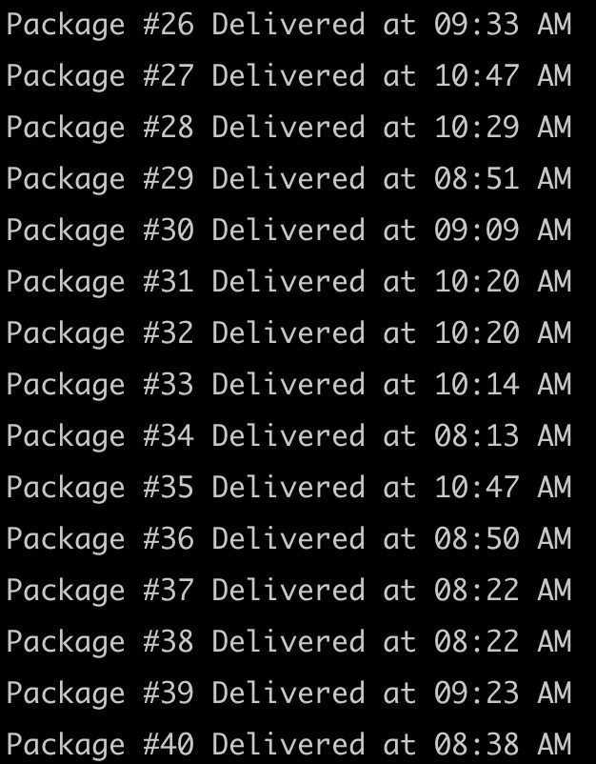

H.  Run your code and provide screenshots to capture the complete execution of your code.

